Michael and Patti Cheikin

34820 Capstan Lanee

Lewes, DE 19958

cell 610-639-6034,5

cheikinm@msn.com patti.cheikin@gmail.com

November 29, 2022

Lloyd Evans

Evans Contracting LLC

26907 Avalon Rd

Georgetown DE 19447

302-515-4272

evanstilellc@gmail.com

**BY CERTIFIED MAIL 7009 1410 0000 7062 2898**

Dear Lloyd:

Enclosed is check #803 for $2503.00 as per your final bill of 11/14/2022.

We are paying you in dispute as several parts of the job are not completed, including but not limited to painting, tiling, flooring, molding, carpentry and cleaning.

In addition, your final bill lists $600.00 to remove flooring, which on 10/14/2022 Patti and Michael did with Jake. Jake was not there more than three hours (and Michael had to complete the job). Similarly, you charged $1200 to repair a siding/window issue that did not require any new materials other than caulking and took no more than 6 man hours. Your original proposal for this job was $500. We did not agree to this high figure which is close to the cost of a new window. On reviewing your prior bills, we have discovered areas that were double-billed.

As we have discussed, our mutual intention is to be reasonable and fair with each other. Unfortunately this leak has derailed the project. We trust that you will work cooperatively with the various professionals who are engaged to repair and restore our home. We look forward to reviewing any discrepancies and settling with you in the near future.

Sincerely,

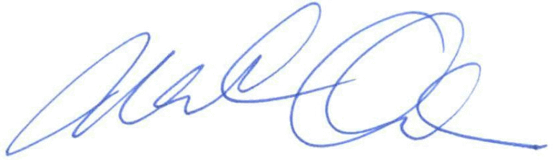

Michael and Patti Cheikin

**Envelope to:**

Cheikin

34820 Capstan Lane

Lewes, DE 19958

**Lloyd Evans**

**Evans Contracting LLC**

**26907 Avalon Rd**

**Georgetown DE 19447**

**Certified Receipt:**

Lloyd Evans

Evans Contracting LLC

26907 Avalon Rd

Georgetown DE 19447

**Green Card Back:**

Lloyd Evans

Evans Contracting LLC

26907 Avalon Rd

Georgetown DE 19447

**Green Card Front:**

**Cheikin**

**245 Bradford Cir**

**Blue Bell PA 19422**

**SASE:**

Keith D. Black, PC

5173 Merrick Road

Massapequa Park, NY 11762

**Patti Cheikin**

**245 Bradford Circle**

**Blue Bell, PA 19422**