Michael and Patti Cheikin

34820 Capstan Lanee

Lewes, DE 19958

cell 610-639-6034,5

cheikinm@msn.com patti.cheikin@gmail.com

May 9, 2022

Ian McCarty, owner

Coastal Home Experts LLC

6199 Kirby Rd.

Milford DE 19963

302-505-6423

CERTIFIED MAIL: 7009 1410 0000 7062 2805

**CERTIFIED MAIL, EMAIL AND HAND DELIVERED**

**CEASE AND DESIST**

To Ian McCarty:

We have discovered that you are not a registered General Contractor. You have not communicated with us in almost a month and have breached our contract.

**You may no longer enter or do any work on our property. You do not have permission to leave your trailer on our driveway.**

**You must remove your trailer from our property by Noon on Wednesday May 11 2022 Noon (48 hours from this email/letter) or we will have it removed.**

Sincerely,

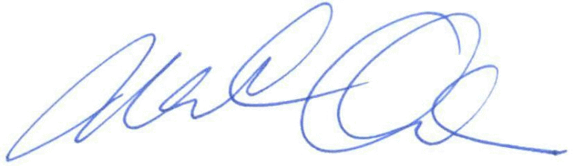

Michael and Patti Cheikin

**Envelope to:**

Cheikin

34820 Capstan Lane

Lewes, DE 19958

**Ian McCarty, owner**

**Coastal Home Experts LLC**

**6199 Kirby Rd.**

**Milford DE 19963**

**Certified Receipt:**

**Ian McCarty, owner**

**Coastal Home Experts LLC**

**6199 Kirby Rd.**

**Milford DE 19963**

**Green Card Back:**

**Ian McCarty, owner**

**Coastal Home Experts LLC**

**6199 Kirby Rd.**

**Milford DE 19963**

**Green Card Front:**

**Cheikin**

**245 Bradford Cir**

**Blue Bell PA 19422**

**SASE:**

Keith D. Black, PC

5173 Merrick Road

Massapequa Park, NY 11762

**Patti Cheikin**

**245 Bradford Circle**

**Blue Bell, PA 19422**