September 23, 2019

RE: Yasmeen Toney, DOB 11/11/1975

Medical Necessity, Prescription and Provision of Nutriceuticals

To Whom It May Concern:

The Above-Named Patient has been prescribed the following supplements for the diagnoses listed. These are purchased at my office or through my on-line store that is provided as a service to improve patient compliance. Review with tax and legal experts has verified that these purchases meet requirements for an HSA as described in the relevant IRS code.

Please feel free to contact me, with a release from the patient, if you have any questions.

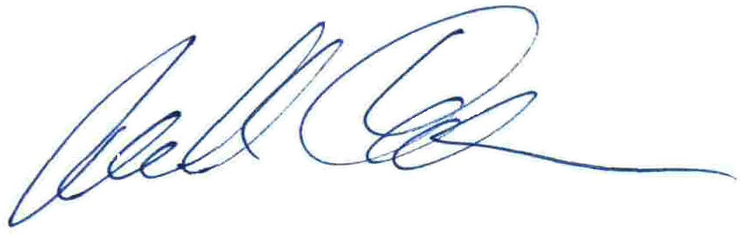Thank you.

Michael Cheikin MD

PA Medical License MD-040161E

DIAGNOSES

s/p Pituitary Adenoma

High Prolactin

Breast Secretions

Hypothyroid

Recurrent shingles

**Rx**

PHARMACEUTICAL SCHEDULE REVISED BB BR LU DI SL NOTE

c T3=liothyroi 5 01/27/2016 1

i T4=Tirosint 150 11/25/2015 1 4 days 100, 1 day

NUTRICEUTICALS Size BB BR LU DI SL NOTE

Black Seed Oil_______|1-2___|______|______|1-2___|______|p = protocol

Candibct AR __________|______|______|______|______|______|

Candibct BR __________|______|______|______|______|______|

i Cheik-I-Dine 1 drop____|______|______|______|10____|______|

Digestive En complex___|______|~2____|~2____|~2____|______|

Ferrochel Ir 27mg______|______|______|______|1_____|______|

o Lysine (l-) 500mg_____|______|1_____|(1)___|1_____|(1)___|

r Mag Taurate 125mg_____|______|1_____|1_____|______|______|

Magnesium Gl 100mg_____|______|______|______|______|4_____|

a Minerals, Co 3caps_____|______|1_____|______|1_____|______|

Niacinamide 500mg_____|______|1_____|______|1_____|______|

O3=ResQ EPA/ 750mg_____|______|______|2_____|2_____|______|

Potassium Ci 99MG______|2_____|______|______|______|2_____|

Ther-Biotic 25B_______|______|______|______|______|2_____|

Tyrosine (l- 500mg_____|______|1_____|______|1_____|______|

i Ultragenesis multi_____|______|1_____|______|1_____|______|

Vit A Retiny 10,000____|______|1_____|______|1_____|______|

Vit C-1000 C 1000MG____|______|3_____|4_____|4_____|5_____|

r Vit D W K 2000 iu___|______|1_____|______|1_____|______|

Zinc (tri) 30 mg_____|______|1_____|______|1_____|______|

ZZ Bio-Fem PM Complex___|______|2_____|2_____|2_____|______|