DATE HERE

RE: Medical Necessity, Prescription and Provision of Nutriceuticals

To Whom It May Concern:

The Above-Named Patient has been prescribed the following supplements. These are purchased at my office or through my on-line store that is provided as a service to improve patient compliance. Review with tax and legal experts has verified that these purchases meet requirements for an HSA as described in the relevant IRS code.

In my medical opinion, as a licensed Medical Doctor, these nutriceuticals are medically

necessary for the treatment of this patient.

Please feel free to contact me, with a release from the patient, if you have any questions.

Thank you.

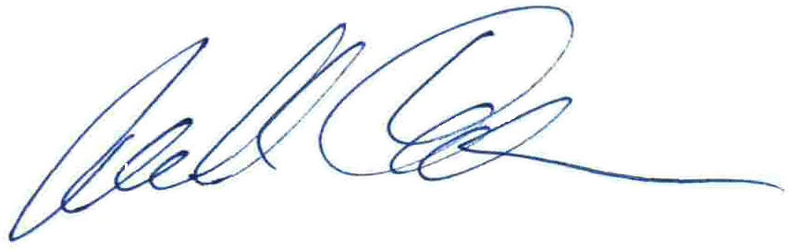

Michael Cheikin MD

PA Medical License MD-040161E