Victoria Mcgarrity, Age 53, DOB 04/24/1966, P# 7374

.

Visit # 8, Page 2 of 2

Wednesday, 09/04/2019

DIAGNOSES

Fatigue

Hashimotos

L arm pain

Worsening PMS

s/p sinus surgery

PHARMACEUTICAL SCHEDULE REVISED BB BR LU DI SL NOTE

c T3=Cytomel 5 mcg 12/12/2014 1 1

c Tirosint 88 mcg 04/05/2016 1

NUTRICEUTICALS Size BB BR LU DI SL NOTE

Cheik-I-Dine 10mL______|______|______|______|1_____|______|

a Dhea 5mg 5MG_______|______|______|______|______|______|

i Ferrochel Ir 27mg______|______|1_____|______|1_____|______|

Mag Taurate 125mg_____|______|2_____|______|______|2_____|

a Mag Taurate 125mg_____|______|______|______|______|______|

o Melatonin 0.5 mg____|______|______|______|______|1-9___|

i Metagest 270 650 mg____|______|1-2___|2-4___|2-5___|______|"optimize"

a Metagest 90t 650MG_____|______|______|______|______|______|

a O6=evenng Pr 500mg_____|______|______|______|______|______|

ResQ Omega-3 750mg_____|______|______|1>2___|1>2___|______|

Ultra Floro complex___|______|1_____|______|1_____|______|

Ultra Genes multi_____|______|2_____|______|2_____|______|

a Vit C-1000 C 1000MG____|______|1_____|______|1_____|______|

a Vit D W K 2000 iu___|______|______|______|______|______|

a ZZZZMinerals 3caps_____|______|1_____|______|1_____|______|

DATE HERE

RE: Medical Necessity, Prescription and Provision of Nutriceuticals

To Whom It May Concern:

The Above-Named Patient has been prescribed the following supplements for the diagnoses listed. These are purchased at my office or through my on-line store that is provided as a service to improve patient compliance. Review with tax and legal experts has verified that these purchases meet requirements for an HSA as described in the relevant IRS code.

Please feel free to contact me, with a release from the patient, if you have any questions.

Thank you.

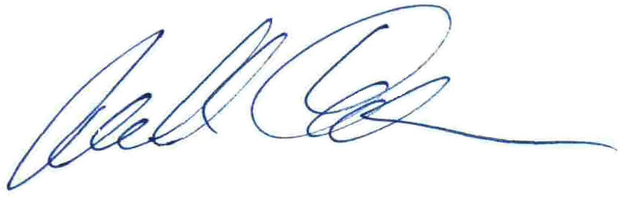

Michael Cheikin MD

PA Medical License MD-040161E