Diane Horan, Age 53, DOB 08/29/1966, P# 7279

.

Visit # 47, Page 2 of 2

Wednesday, 07/31/2019

DIAGNOSES

Fatigue/Sleep Disorder

Pains hips

Hashimotos, on Armour

s/p RDS L foot 2000-2005

s/p L neuroma 1997-resect 1999

Rosacea

PHARMACEUTICAL SCHEDULE REVISED BB BR LU DI SL NOTE

A a Effexor 37.5 mg 04/11/2017 1 1 staff

A d Lorazepam 04/11/2017 z staff

U d NatureThroid 1 gr 04/11/2017 2 2.q q = quarter

c Trazadone 50 mg 06/19/2019 1

NUTRICEUTICALS Size BB BR LU DI SL NOTE

Betaine Hcl 648MG_____|______|5_____|5_____|5_____|______|staff

p Candibct AR __________|______|______|______|______|______|from order06/14

p Candibct BR __________|______|______|______|______|______|

p Candisol complex___|______|______|______|______|______|

p Cdp-Choline 250mg_____|______|______|______|______|______|

a Cheik-I-Dine 1 drop____|______|______|______|______|______|

a Comprehensiv __________|______|______|______|______|______|

DHEA 5 mg ca 5 mg______|3_____|______|______|______|______| staff 04/13/17

Digest Enz __________|______|______|2_____|2_____|______|04/11/2017staff

a Evening Prim 500mg_____|______|______|______|______|______|

Fish Oil __________|______|______|2_____|2_____|______|staff

Glycine 500m 500MG_____|______|______|4_____|______|4_____|from order06/14

a ZZInositol 900mg_____|______|______|______|______|______|

p InterFase Pl complex___|______|______|______|______|______|

Licorice Roo 400mg_____|2_____|______|______|______|______|

Lugols 1d=2mg____|______|______|______|______|1_____|04/12/2017staff

a Magnesium Gl 100mg_____|______|______|______|______|______|

a Magnesium Ta 400mg_____|______|______|______|______|______|

p Melatonin 0.5 mg____|______|______|______|______|1-9___|2-3 nights/wkst

Metagest 270 650 mg____|______|______|______|______|______|

Minerals, Sp __________|______|______|______|______|______|staff

Nac N Acetyl 600 mg____|______|1_____|______|1_____|______|staff

Niacin 500 500mg_____|______|1_____|______|______|2_____|from order05/03

Potassium Ci 99MG______|______|2_____|______|2_____|______|staff

Pregnenolone 10 mg_____|2_____|______|______|______|2_____|from order06/14

Selenium 200mcg____|______|______|______|______|______|

Taurine (l-) 1000mg____|______|______|______|______|1_____|04/12/2017staff

Ther-Biotic 25B_______|______|______|______|______|2_____| staff 04/10/17

Tyrosine (l- 500mg_____|5_____|______|______|______|______|04/11/2017staff

Ultragenesis multi_____|______|______|______|______|______|

Vit A Retiny 10,000____|______|1_____|______|1_____|______|staff

Vit C-1000 C 1000MG____|______|5_____|5_____|5_____|______|04/11/2017staff

a Vit D 5000 I 5000______|______|______|______|______|______|

Vit D W K 2000 iu___|______|3_____|______|______|______| staff 04/10/17

Vit E 400 IU____|1_____|______|______|______|______|04/11/2017staff

a Vital-Zymes 800mg_____|______|______|______|______|______|

a Vital-Zymes complex___|______|______|______|______|______|

Zinc Picolin 50mg______|______|1_____|______|______|1_____|staff

ZZLithium Or 4.8mg_____|______|1_____|______|1_____|______| staff 04/11/17

DATE HERE

RE: Medical Necessity, Prescription and Provision of Nutriceuticals

To Whom It May Concern:

The Above-Named Patient has been prescribed the following supplements for the diagnoses listed. These are purchased at my office or through my on-line store that is provided as a service to improve patient compliance. Review with tax and legal experts has verified that these purchases meet requirements for an HSA as described in the relevant IRS code.

Please feel free to contact me, with a release from the patient, if you have any questions.

Thank you.

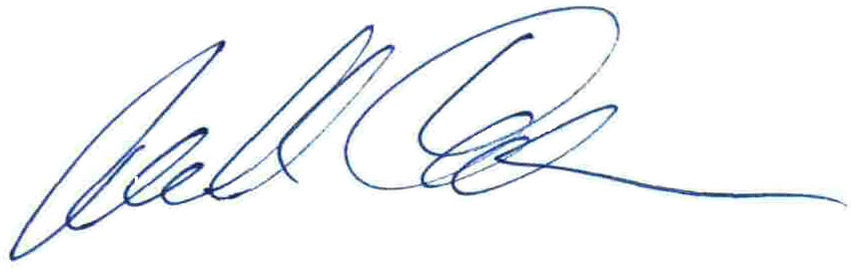

Michael Cheikin MD

PA Medical License MD-040161E