October 9, 2019

Diane Horan, Age 53, DOB 08/29/1966, P# 7279

RE: Medical Necessity, Prescription and Provision of Nutriceuticals

To Whom It May Concern:

The Above-Named Patient has been prescribed the following supplements for the diagnoses listed. These are purchased at my office or through my on-line store that is provided as a service to improve patient compliance. Review with tax and legal experts has verified that these purchases meet requirements for an HSA as described in the relevant IRS code.

Please feel free to contact me, with a release from the patient, if you have any questions.

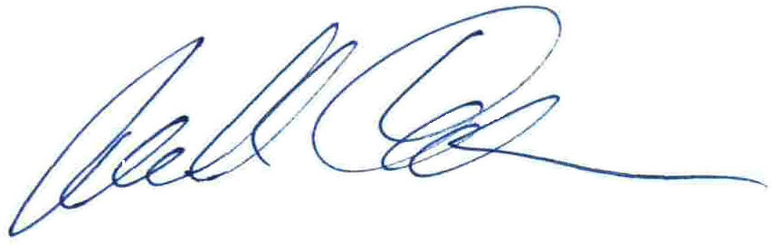Thank you.

Michael Cheikin MD

PA Medical License MD-040161E

NUTRICEUTICALS Size BB BR LU DI SL NOTE

Betaine Hcl 648MG_____|______|5_____|5_____|5_____|______|

p Candibct AR __________|______|______|______|______|______|

p Candibct BR __________|______|______|______|______|______|

p Candisol complex___|______|______|______|______|______|

p Cdp-Choline 250mg_____|______|______|______|______|______|

a Cheik-I-Dine 1 drop____|______|______|______|______|______|

a Comprehensiv __________|______|______|______|______|______|

DHEA 5 mg ca 5 mg______|3_____|______|______|______|______|

Digest Enz __________|______|______|2_____|2_____|______|

a Evening Prim 500mg_____|______|______|______|______|______|

Fish Oil __________|______|______|2_____|2_____|______|

Glycine 500m 500MG_____|______|______|4_____|______|4_____|

a ZZInositol 900mg_____|______|______|______|______|______|

p InterFase Pl complex___|______|______|______|______|______|

Licorice Roo 400mg_____|2_____|______|______|______|______|

Lithium Or 4.8mg_____|______|1_____|______|1_____|______|

Lugols 1d=2mg____|______|______|______|______|1_____|

a Magnesium Gl 100mg_____|______|______|______|______|______|

a Magnesium Ta 400mg_____|______|______|______|______|______|

p Melatonin 0.5 mg____|______|______|______|______|1-9___|

Metagest 270 650 mg____|______|______|______|______|______|

Minerals, Sp __________|______|______|______|______|______|

Nac N Acetyl 600 mg____|______|1_____|______|1_____|______|

Niacin 500 500mg_____|______|1_____|______|______|2_____|

Potassium Ci 99MG______|______|2_____|______|2_____|______|

Pregnenolone 10 mg_____|2_____|______|______|______|2_____|

Selenium 200mcg____|______|______|______|______|______|

Taurine (l-) 1000mg____|______|______|______|______|1_____|

Ther-Biotic 25B_______|______|______|______|______|2_____|

Tyrosine (l- 500mg_____|5_____|______|______|______|______|

Ultragenesis multi_____|______|______|______|______|______|

Vit A Retiny 10,000____|______|1_____|______|1_____|______|

Vit C-1000 C 1000MG____|______|5_____|5_____|5_____|______|

a Vit D 5000 I 5000______|______|______|______|______|______|

Vit D W K 2000 iu___|______|3_____|______|______|______|

Vit E 400 IU____|1_____|______|______|______|______|

a Vital-Zymes 800mg_____|______|______|______|______|______|

a Vital-Zymes complex___|______|______|______|______|______|

Zinc Picolin 50mg______|______|1_____|______|______|1_____|